

**Actividad [2] – [Develop a project** **]**

**[Ingles para los negocios 1]**

**Ingeniería en Desarrollo de Software**

**Tutor: Fatima Fernandez**

**Alumno: Manuel Enrique Ramirez Lopez**

**Fecha: 06/02/2022**

**Indice**

*Desarrollo* 1

*Capturas de pantalla* 2

*Conclucion* 3

# 

# *Desarrollo*

# To represent what we want to convey to an audience, we need to have our objectives very clear, for this, we must carry out an in-depth investigation on the topic that we want to solve together.

# The steps to represent our proposal for change are as follows:

# 1-Clear objective

# 2-Be concise

# 3-Do not deviate from the topic

# *Capturas de pantalla*

# 

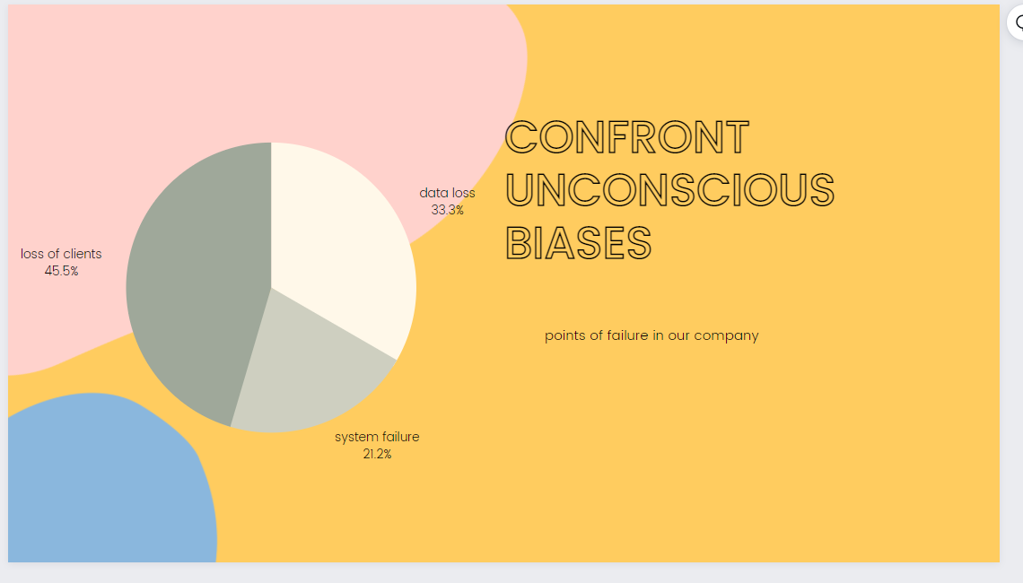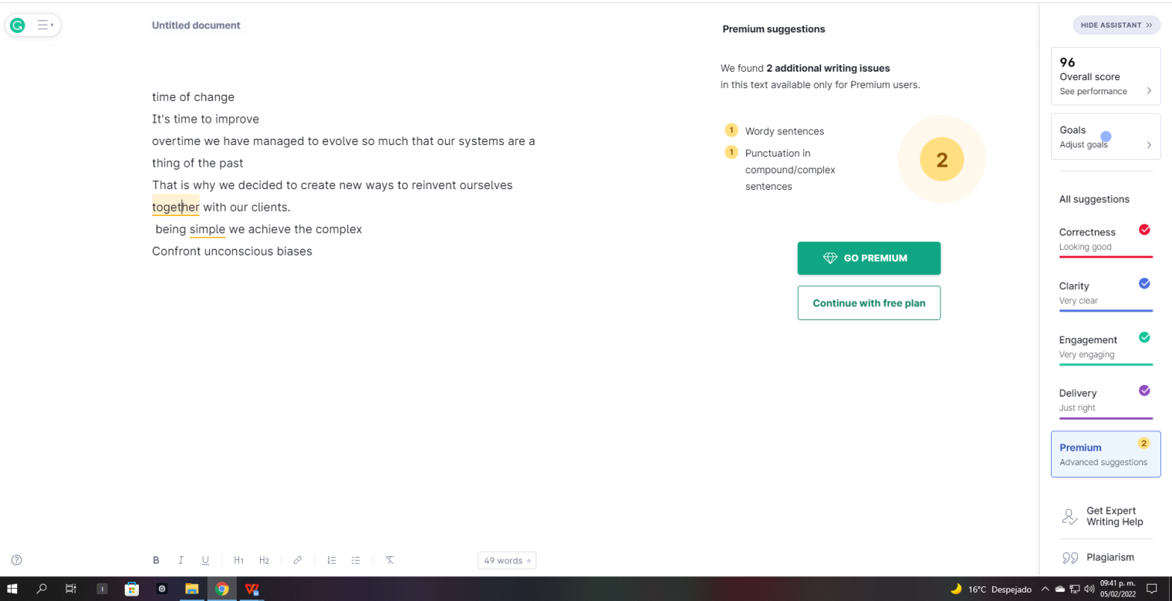

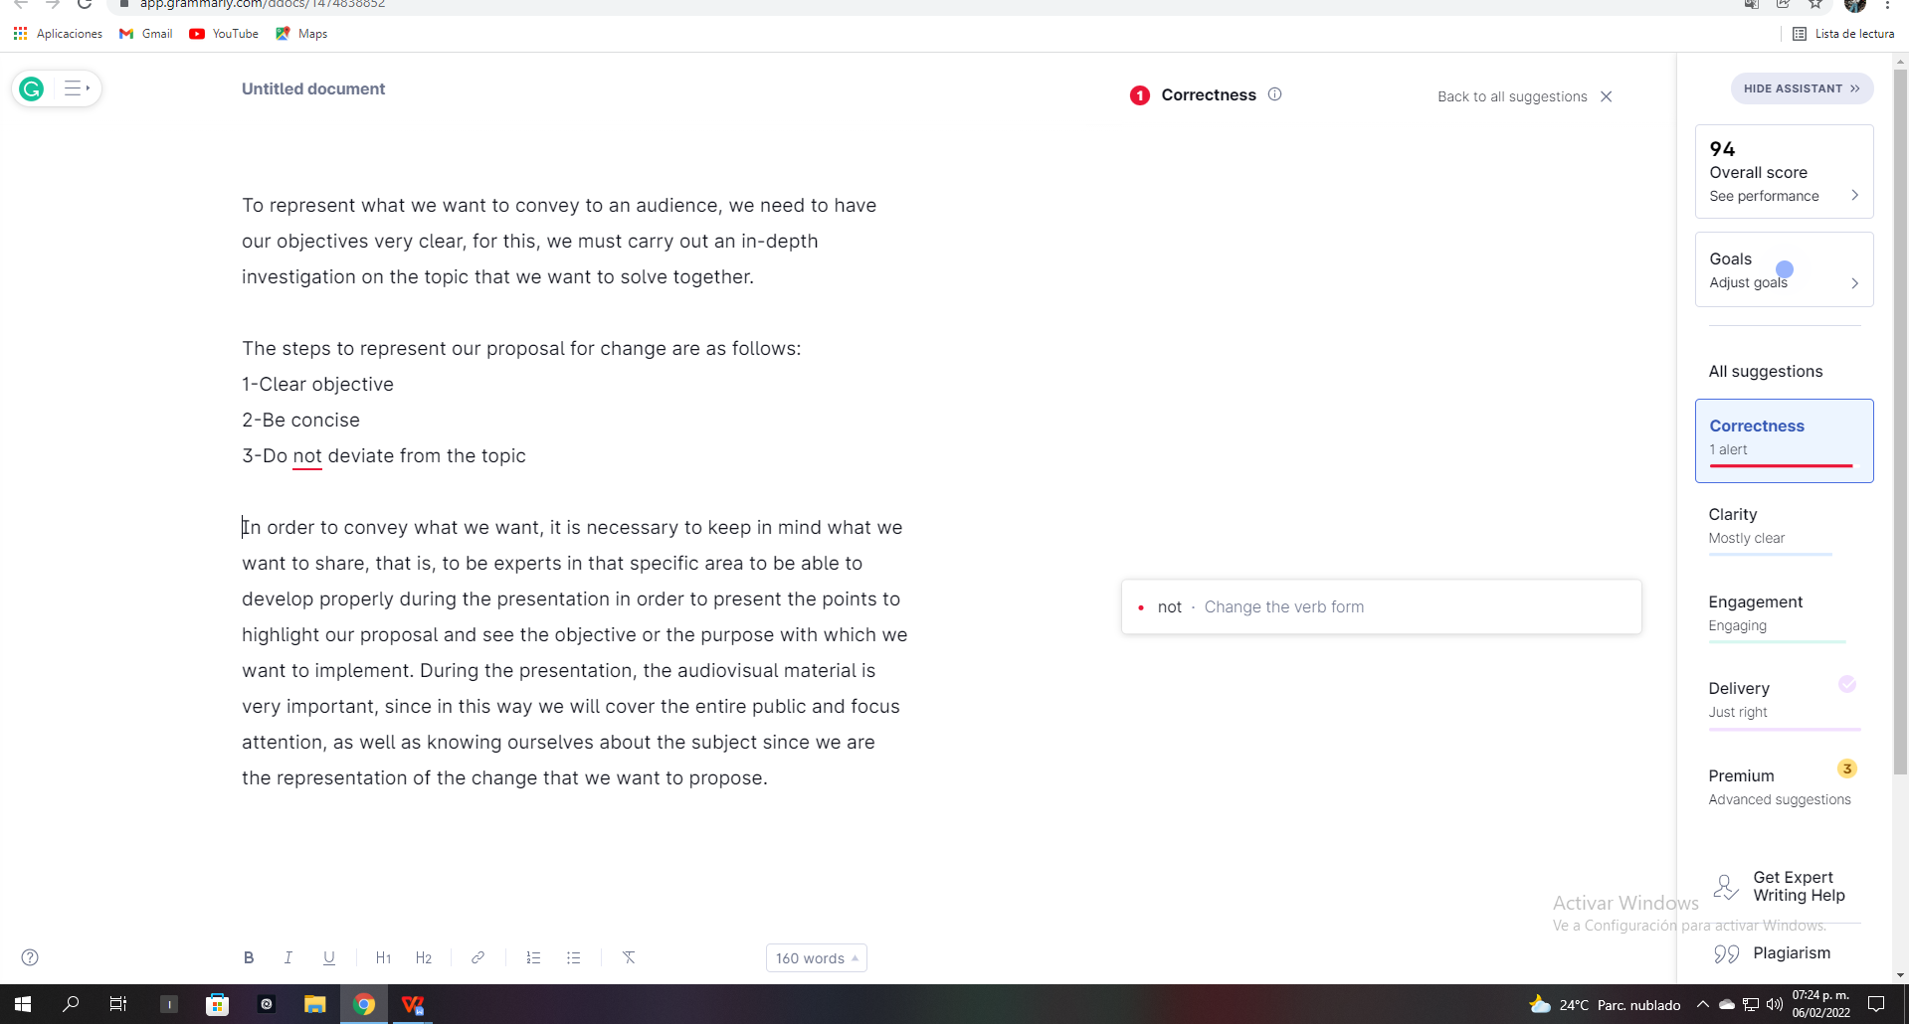

# *Conclucion*

In order to convey what we want, it is necessary to keep in mind what we want to share, that is, to be experts in that specific area to be able to develop properly during the presentation in order to present the points to highlight our proposal and see the objective or the purpose with which we want to implement. During the presentation, the audiovisual material is very important, since in this way we will cover the entire public and focus attention, as well as knowing ourselves about the subject since we are the representation of the change that we want to propose.